## Project roadmap

**Day one :**

Team Discussion on how to build the final Solution and to understand which IBM services to use.

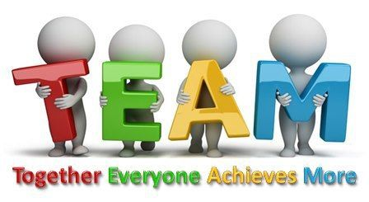

**Day two:**

Working towards creating the solution using IBM services – Watson Assistant using the Intent creation, creating JSON files and adding skills to it and the GitHub Repository.

And Test Test Test !!!

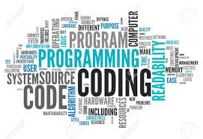

**Day Three:**

Integrating the solution to the GitHub Repository and creating the documentation for submission and finalizing everything.



In order to add the email part, need some more time so that it’s fully functional as per our requirement.